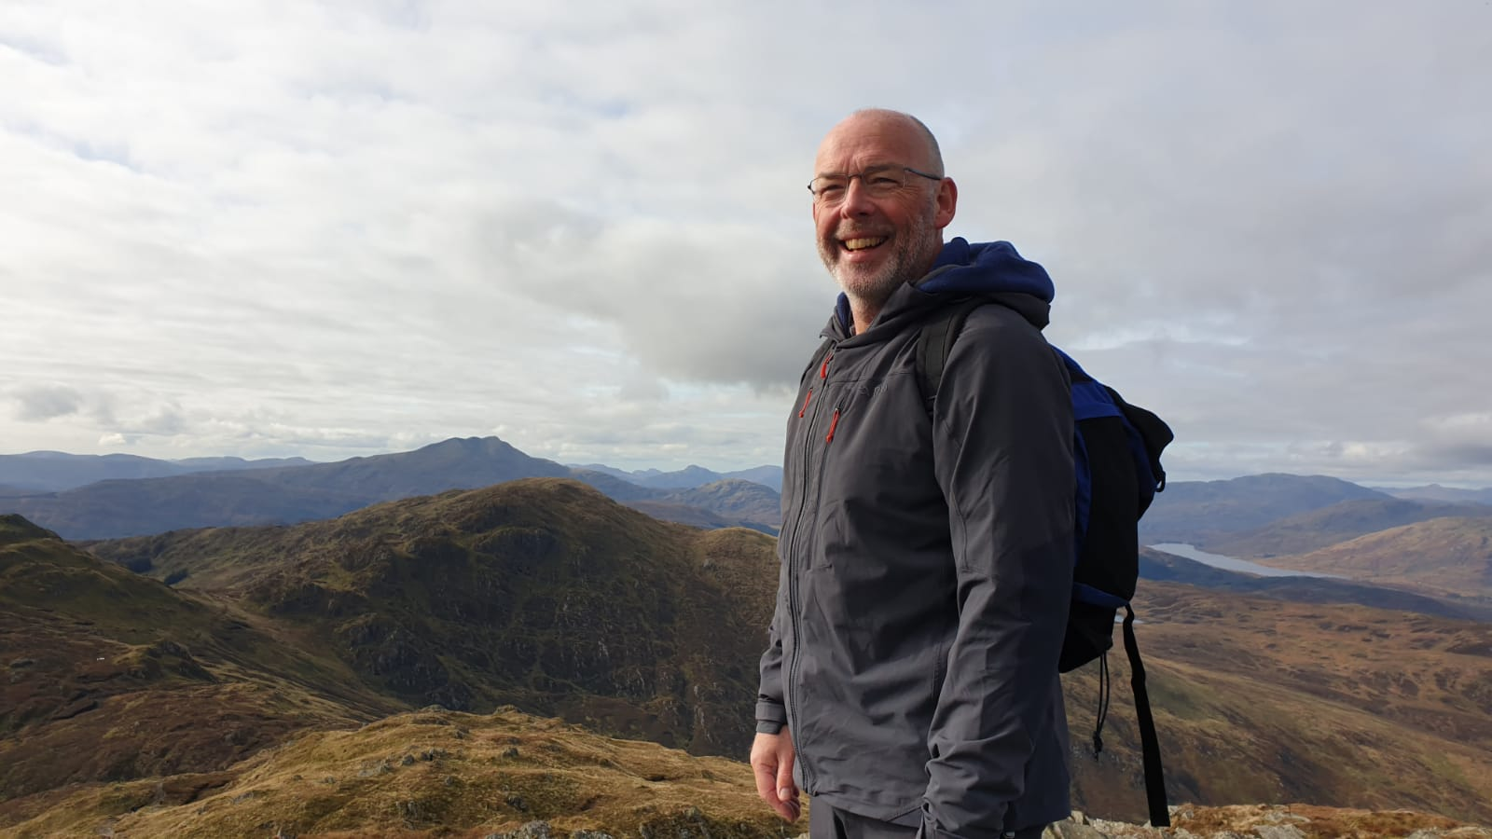

John Gibson has held a number of roles in UK dentistry including Professor of Medicine in Relation to Dentistry in the University of Glasgow, Chairman of Fitness to Practise at the GDC, Chairman of Dental Protection, and Associate Postgraduate Dental Dean for Scotland. His most recent role was as Head of the Institute of Dentistry and Professor of Oral Medicine in the University of Aberdeen. However, that role came to an abrupt end after John’s son, Cameron, died by suicide in October 2019. The resultant carnage for John and his family has changed their lives forever with so many questions: What is suicide? Why our family? Why did Cameron, a seemingly happy and contented young man in a loving family, with everything to live for, decide that this world was no longer a place he wanted to be?

John is part of the Edinburgh SOBS Group and now spends much of his time in the suicide community - walking and talking with those impacted by suicide to develop the concept of “safe spaces” in suicide prevention and postvention (thecanmoretrust.co.uk). Such safe spaces might be found inside our minds, our school classrooms, our workplaces and our homes. He is opening up conversations across the UK, emphasising that suicide can happen to any family or community and so suicide is everyone’s business. He believes that our educational system requires open discussion on suicide and how we equip our young people with the skills to develop a “suicide safety plan”.

John sets off on 13th June 2022 with this message from Land’s End to John O’Groats. Follow him on Instagram: #onemanwalkingamilliontalking and please think about joining John for a section of the 1,200 miles of LEJoG and join in the conversation! John’s JustGiving page can be found at: www.justgiving.com/LEJoG-John-Gibson THANK YOU!

